**Daily Scrum or Standup Meeting**

Team name: _Team10________________________

Scrum Master: _Zach Hawkes______________________

Date:__3-19-19_____________________________

|  |  |  |  |
| --- | --- | --- | --- |
| **Team Member** | **What did you do since the last scrum?** | **What do you plan to do before the next scrum?** | **What obstacles do you have?** |
| George | Enjoyed Spring Break  Setup up and got running the Django Project | Maybe the movie view page? | need to educate myself a lot |
| Zach | Got a user login page up and running and modified git tracking to untrack .pyc files and the database files | Implement a user session token system and create a create user form |  |
| Tanner | Set up and got the django project running. | Create movie model.  Create initializer for dummy data | Need to research/remember how to do everything with django. |
| Nick | Setup up and got running the Django Project | Post A Movie Page | Writing good unit tests. And using the movie api from django data base |
|  |  |  |  |

# Burndown

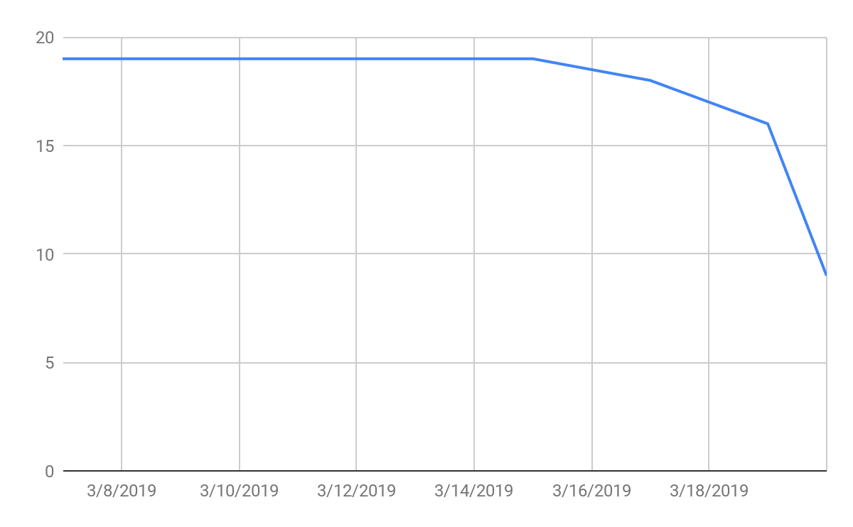

# Screenshot of your task board

